**DAILY ONLINE ACTIVITIES SUMMARY**

|  |  |  |  |  |  |  |  |  |
| --- | --- | --- | --- | --- | --- | --- | --- | --- |
| **Date:** | **04-06-2020** | | | | | **Name:** | **D Jasmine Joyline** | |
| **Sem & Sec** | **VI Sem A** | | | | | **USN:** | **4AL17CS024** | |
| **Online Test Summary** | | | | | | | | |
| **Subject** | | **Operating System** | | | | | | |
| **Max. Marks** | | **30** | | **Score** | | | **19** | |
| **Certification Course Summary** | | | | | | | | |
| **Course** | **Python Bootcamp 2020:Build 15 working applications and games** | | | | | | | |
| **Certificate Provider** | | | **Udemy** | | **Duration** | | | **32hr** |
| **Coding Challenges** | | | | | | | | |
| **Problem Statement:** Python program to combine the stringsPython Program to display list in given format | | | | | | | | |
| **Status:Completed** | | | | | | | | |
| **Uploaded the report in Github** | | | | | **Yes** | | | |
| **If yes Repository name** | | | | | <https://github.com/alvas-education-foundation/D_Jasmine_Joyline/tree/master/daily_progress> | | | |
| **Uploaded the report in slack** | | | | | **Yes** | | | |

Online Test Details:

OS IA TEST

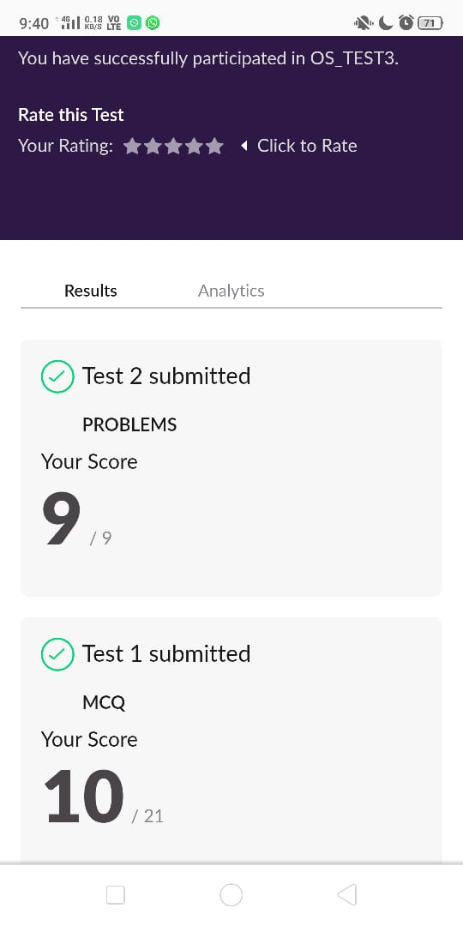

Certification Course Details:

Module that I have completed today:

* Turtle graphics
* Project8:Caterpillar game
* Project9:Matchmaker

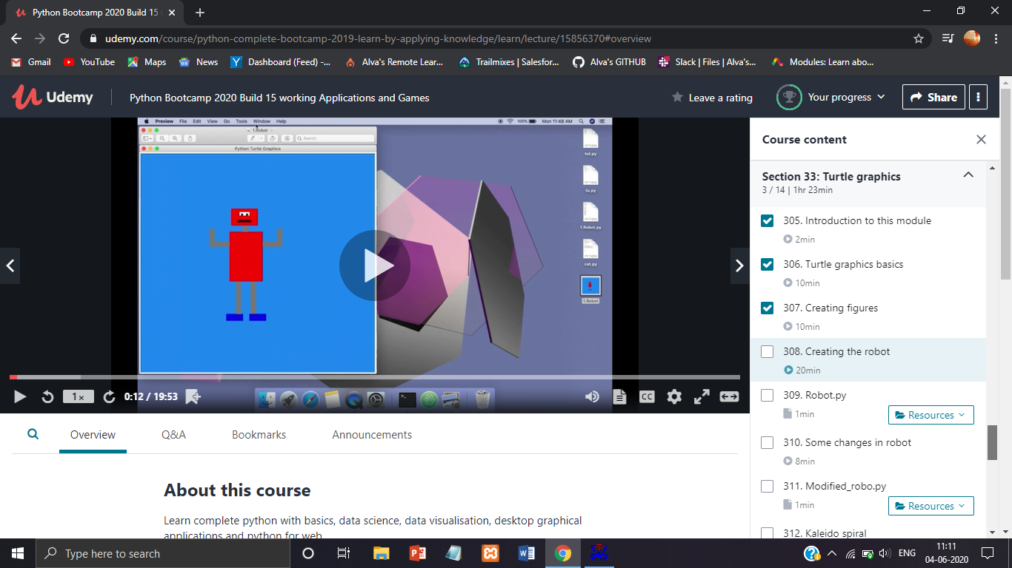

Online Java classes

* Aggregation
* Association
* Composition

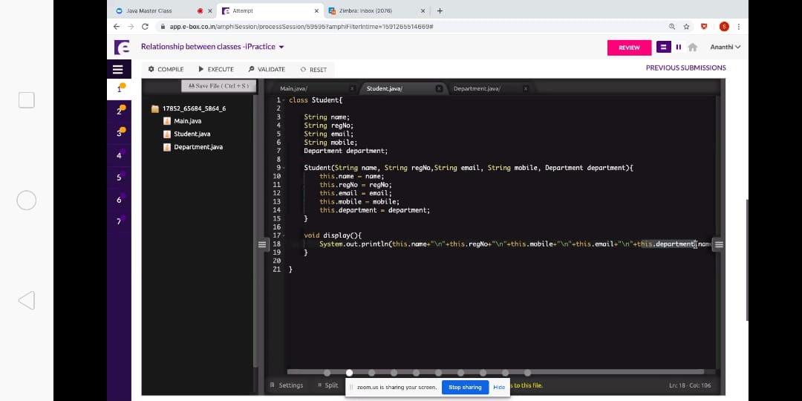

Coding Challenges Details:

## 1.  Python program to combine the strings

Description:Take two strings, return a string of the form short+long+short, with the shorter string on the outsides and the longer string on the inside. The strings will not be the same length, but they may be empty (length 0).

Eg:  
Str1= 'Hello'  
Str2= 'Hi'  
Combined_str('Hello', 'Hi') ='HiHelloHi'

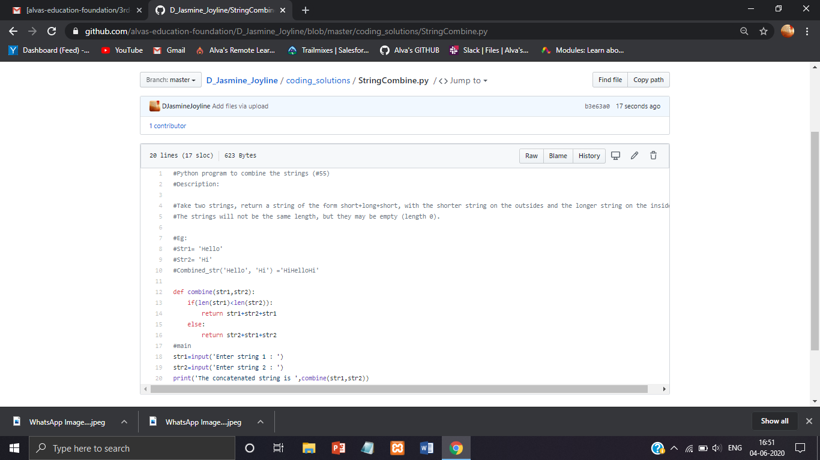

2. Python Program to display list in given format

Problem statement:  
Take a list of length 3 containing integers, find out which is larger, first or last one and set all the elements in the list to be that value. Print the updated list  
eg:  
1)Input - Given list: [1, 2, 3] Output- [3,3,3]  
2)Input - Given list: [2, 11, 3] Output- [3,3,3]

